**Department of Veterans Affairs**

***Pharmacy Remote Prescription Manager***

**PSO_INNOV 1.0**

**Technical Manual**

VA logo

***September 2014***

**Version 1.****0**

Revision History

|  |  |  |  |
| --- | --- | --- | --- |
| Date | Version | Description | Author |
| 9/15/2014 | 1.0 | Draft | Brad Fisher/Jim Horner |

**Table of Contents**

1. Pharmacy Remote Prescription Manager 3

1.1. Introduction 3

1.2. About this Guide 3

1.3. Section 508 of the Rehabilitation Act of 1973 3

1.4. Related Documents 3

1.5. Document Conventions 3

2. General Information 3

2.1. Architectural Scope 3

2.1.1. RESTful Web Services 4

2.2. System Performance 4

2.2.1. Desktops/Workstations 4

2.2.2. Disk Space 5

2.2.3. Namespace and Number Space 5

2.2.4. Timeouts 5

2.2.5. Response Times 5

3. Parameters 6

4. Routines 6

4.1. Pharmacy Remote Prescription Manager Routines 6

4.2. Pharmacy Remote Prescription Manager Checksums 6

5. Files and Globals 6

5.1. Globals 6

5.2. Files 7

5.2.1. File Descriptions 7

6. Exported Remote Procedure Calls 9

7. Exported Options 9

7.1. Pharmacy Remote Prescription Manager Options 9

8. Security 10

8.1. Secure Sockets Layer (SSL) 10

8.2. Authentication and Authorization 10

8.3. Remote Prescription Locking 10

9. Protocols 10

9.1. Protocols 10

10. List Templates 10

10.1. Pharmacy Remote Prescription Manager List Templates 10

# Pharmacy Remote Prescription Manager

## Introduction

PSO Innovations is a necessary and valuable contribution to providing nationwide pharmacy refill and management to the Veteran population. The innovation is focused on the delivery of VA prescription management as a service to the mobile population of Veterans.

The Pharmacy Remote Prescription manager uses HL7, HL logical links, and RESTful services to build messages directed to remote VAMC’s and clinics. These remote messages request prescription data from each of the facilities in relation to the currently selected patient. Modifications have been integrated into the routines that drive the PSO LM BACKDOOR orders option. The Pharmacy Remote Prescription Manager allows the user to:

* View prescriptions from other facilities that the veteran has been seen at
* Refill ‘active’ prescriptions that have refills remaining
* Partially fill active prescriptions
* View activity for both local and remote actions on prescriptions

## About this Guide

*Pharmacy Remote Prescription Manager* provides technical information for configuring, managing, and troubleshooting local (M Server) components of the PSO INNOVATIONS application.

## Section 508 of the Rehabilitation Act of 1973

N/A

## Related Documents

* Pharmacy Remote Prescription Manager User Guide
* Pharmacy Remote Prescription Manager Installation Guide
* Pharmacy Remote Prescription Manager System Design Document
* Pharmacy Remote Prescription Manager User Manual
* Pharmacy Remote Prescription Manager Technical Manual

## Document Conventions

**Bold type** indicates application elements (views, panes, links, buttons, text boxes, and so forth) and key names. Key names appear in angle brackets <>. *Italicized text* indicates special emphasis or user responses. ALL CAPS indicates M routines and options. … (ellipses) indicate omitted text.

# General Information

## Architectural Scope

The Pharmacy Remote Prescription manager uses HL logical links, HL application protocols, and RESTful services to send and receive messages related to remote prescriptions. Once a user enters the option PSO LM BACKDOOR orders, an HL7 QBP^Q13 message is built using the treating facility list for the selected patient to populate the PID segment. The HL7 message is sent to the Pharmacy Manager. Upon receipt of the HL7 query message, the Pharmacy Manager orchestrates a series of REST calls to each VistA facility identified in the PID segment to retrieve a list of active prescriptions for the patient. The per VistA active prescriptions lists are aggregated together and sent back in the HL7 response.

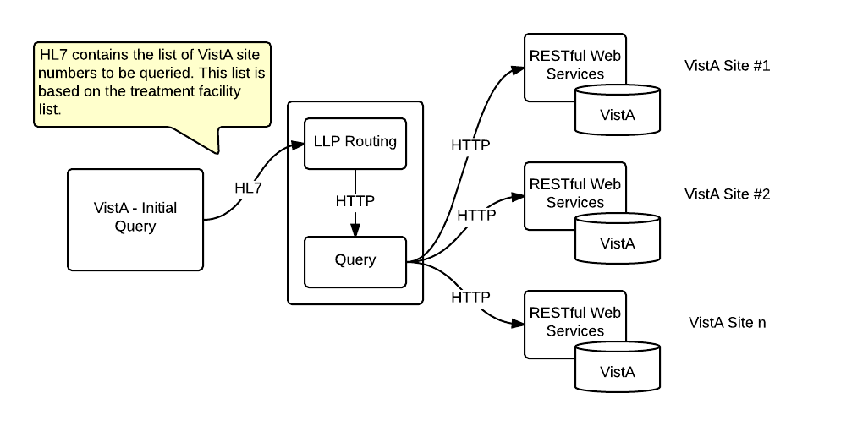

In the event that a provider decides to initiate a refill or partial fill for a remote prescription, an HL7 RDS^O13 message will be sent to the Pharmacy Manager. The Pharmacy Manager will direct the request to the appropriate site. The remote system executes the refill or partial fill action by locking the prescription, update the data for the refill or partial fill and unlocking the prescription.

Once the remote system has determined that the refill or partial fill was completed successfully, the label data will be created. Existing API’s are leveraged to create the label data. This allows consistent label creation. It also ensures that the label data appears as though it would at the ‘originating’ facility.

The success or failure of the refill or partial fill and the label data (as appropriate based on success) is sent back to the initiating site via HL7 response and ^XTMP population in the case of the label data. The refill and partial fill workflow is shown below.

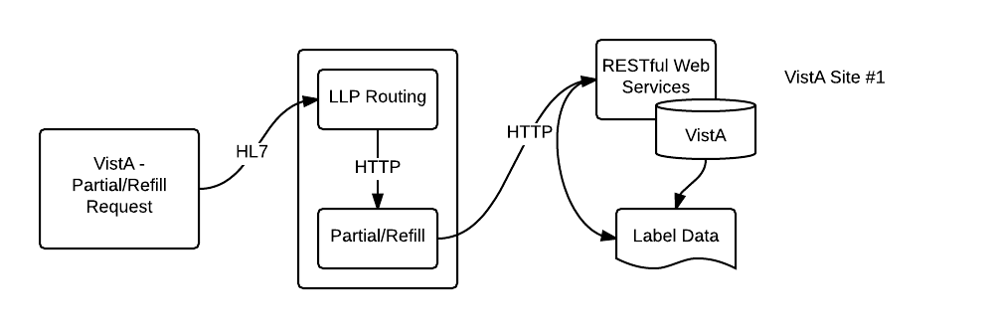

### RESTful Web Services

The RESTful web services run in a Java application server on the same machine as the VistA instance. The RESTful web services use Intersystems Cache Global API to read and write data to the VistA data store as well call VistA MUMPS functions.

The web services use standard Java application server security defined in the web.xml configuratoin. The default implementation uses a security authentication filter that relies on the MUMPS CHECKAV^XUSRB function to authenticate a username and password as a access and verify code; respectively.

## System Performance

### Desktops/Workstations

Workstations should comply with VA Desktop Minimum Acceptable Configurations (<http://vaww.vairm.vaco.va.gov/VADesktop>). In addition, users’ workstations should meet the minimum hardware requirements for running Adobe Flash Player.

Minimum Hardware Requirements

| Platform | CPU | RAM |
| --- | --- | --- |
| Windows | Intel Pentium II 450MHz or faster processor (or equivalent), AMD Athlon 600MHz or faster processor (or equivalent) | 128 MB |
| Macintosh | PowerPC G3 500MHz or faster processor or Intel Core Duo 1.33GHz or faster processor | 128 MB |

Optimal Viewing Requirements

|  |  |  |
| --- | --- | --- |
| Resolution | CPU | RAM |
| 852 x 480 (480 p), 24 frames per second (fps) | Intel Pentium 4 2.33 GHz processor (or equivalent) | 256 MB RAM with 64 MB VRAM |
| 1280 x 720 (720 p), 24–30 fps | Intel Pentium 4 3 GHz processor (or equivalent) | 128 MB RAM with 64 MB VRAM |
| 1920 x 1080 (1080 p) 24 fps | Intel Core Duo 1.8 GHz processor (or equivalent) | 128 MB RAM with 64 MB VRAM |

### Disk Space

TODO – do we need to discuss the remote prescription log file here since it is a new file and will contain remote prescription label data?

### Namespace and Number Space

The namespace for RPPM is PSO. The number space is 52-52.99?.

### Timeouts

Connection and Response timeouts are configurable, see the Installation Manual for location, filename and example. The connection timeout is defined as the time allowed to make a connection from one server to another. The response timeout determines how long the initiating server will wait before giving up on receiving a response. By default, each site has the setting:

* Query Timeout
  + Connection timeout = 5 secs
  + Response timeout = 10 secs
* Refill/Partial Fill Timeout
  + Connection timeout = 5 secs
  + Response timeout = 60 secs

### Response Times

Response times will vary depending on network availability and the aggregate of the timeouts defined above. For example, a Query could take as long as 15 seconds or 5 secs for a connection plus 10 secs for a response. Multiple site queries are run in parallel in blocks of ten (10). Each block could take as long as 15 seconds. For example, a query of 20 sites could take as long as 30 seconds or 20 / 10 * 15 seconds. However, in general, the query time is roughly a few seconds. The label data for a refill or partial fill can take up to a minute to generate, therefore a refill or partial fill could take as long as a minute.

# Parameters

N/A

# Routines

## Pharmacy Remote Prescription Manager Routines

* PSORRX1 builds the HL7 messages that are sent to the Pharmacy Remote Prescription Manager to retrieve, refill, and partial fill prescriptions from another facility. This routine uses the treating facility list to properly build the HL7 information to send to the ‘remote’ site(s).
* PSORREF is the main driving routine for the ‘receiving’ or ‘originating’ facility to process incoming refill requests.
* PSORREF0 is a supporting routine to PSORREF
* PSORREF1 is another supporting routine for PSORREF
* PSORRPA1 is the main routine for processing an incoming partial fill request.
* PSORRD is the routine that controls the PSO LM REMOTE REPORT DETAILS list manager template. This routine is part of the Remote Prescription Report functionality.
* PSORRP assists in prompting for search criteria, and display of the Remote Prescription Report.
* PSORX1 has been modified to call PSORRX1 for retrieval of remote prescription data.
* PSOROS is the driving routine for selection of a ‘remote’ prescription within list manager. This routine controls the list template PSO LM REMOTE ORDER SELECTION.
* PSORWRAP is the wrapper utility for the RESTful calls into Vista.
* PSOORNE2 has been modified to include the display of the remote prescriptions. This routine will display the details related to the remote RX that has been selected.
* PSOORUT1 has been modified to include the display of remote prescriptions within the PSO LM BACKDOOR prescription list. The prescriptions are sorted by facility, and include the same display elements as the local prescription. Each remote facility’s prescription list has an programmatically generated header that separates the prescriptions by status (Active, Suspended, Hold, etc.)

## Pharmacy Remote Prescription Manager Checksums

The following list contains routine names with post-install checksums:

# Files and Globals

## Globals

The Pharmacy Remote Prescription Manager uses the following globals:

^PSRX

^PSRXR

The ^PSRX global holds the prescription data. The ^PSRXR global holds a comprehensive list of information regarding remote refill and partial fill activity.

Global Placement and Protection

|  |  |  |  |  |
| --- | --- | --- | --- | --- |
| Global | Type | Placement | Journal | Protection |
| ^PSRX | Dynamic | No changes should be made to the current placement or settings related to this global | No change | No change |
| ^PSRXR | Static | Place this global in a volume set that can accommodate the following yearly growth rate:  2,000 bytes * visits per year | Yes | RWP or D |

## Files

| File # | File Name | Root Global | Global Protection |
| --- | --- | --- | --- |
| 52 | PRESCRIPTION | ^PSRX | No change |
| 52.09 | REMOTE PRESCRIPTION LOG | ^PSRXR(52.09 | @ |

### File Descriptions

#### Prescription (#52)

The overall prescription file definition remains unchanged, however there are a few modifications that track information related to a remote refill or partial fill. Those changes are listed below, and are isolated to the sub-files for refill and partial fill.

Table REFILL Subfile (#52.1)

| Field Number | Field Name | Pointers | Cross References and Record Indices | Description |
| --- | --- | --- | --- | --- |
| 91 | REMOTE FILL SITE | Pointer to the Institution file (#4) | 52^RFIL | Pointer field  Points to the Instution from which the refill or partial fill request was generated. |
| 92 | REMOTE PHARMACIST | N/A | N/A | Free-text field :  This free text field holds the name of the remote requesting pharmacist. This is the pharmacist that made the remote refill or partial fill request. |
| 93 | REMOTE PHARMACIST PHONE | N/A | N/A | Free-text field:  This is the contact number for the remote (requesting) pharmacist. This is the pharmacist that initiated the remote refill or partial fill request. |

Table PARTIAL DATE subfile (#52.2)

| Field Number | Field Name | Pointers | Cross References and Record Indices | Description |
| --- | --- | --- | --- | --- |
| 91 | REMOTE FILL SITE | Pointer to the Institution file (#4) | 52^PFIL | Pointer field  Points to the Instution from which the refill or partial fill request was generated. |
| 92 | REMOTE PHARMACIST | N/A | N/A | Free-text field :  This free text field holds the name of the remote requesting pharmacist. This is the pharmacist that made the remote refill or partial fill request. |
| 93 | REMOTE PHARMACIST PHONE | N/A | N/A | Free-text field:  This is the contact number for the remote (requesting) pharmacist. This is the pharmacist that initiated the remote refill or partial fill request. |

Table : Remote Prescription Log (#52.09

| Field Number | Field Name | Pointers | Cross References and Record Indices | Description |
| --- | --- | --- | --- | --- |
| .01 | LOG DATE/TIME | N/A | 52.09^B | Date/Time (required):  This is the date/time of the refill or partial fill activity. |
| .02 | PATIENT | Pointer to the PATIENT file (#2) | 52.09^C | Pointer field (required):  This is the pointer to the patient file, which identifies what patient the refill or partial refill request is for. |
| .03 | RX NUMBER | N/A | 52.09^D | Free Text (required):  This is the prescription number as it exsists at the ‘originating’ facility. |
| .04 | SITE NUMBER | Pointer to the INSTITUTION file (#4) | 52.09^E | Pointer field (required):  This is the pointer that identifies which facility was the ‘originating’ facility for this refill or partial fill request. |
| .05 | REQUEST TYPE | N/A |  | Set of codes:  RF for REFILL (outgoing)  PR for PARTIAL FILL (outgoing)  OR for OUTSIDE REFILL (incoming)  OP for OUTSIDE PARTIAL FILL (incoming) |
| .06 | OUTGOING REQUEST PHARMACIST | Pointer to the NEW PERSON file (#200) |  | Pointer field (required):  This is the pointer to the person who iniated a refill or partial fill request to a remote facility. |
| .07 | REMOTE FILLING PHARMACIST | N/A | N/A | Free Text:  This is the textual name of the pharmacist who is requesting a refill or partial fill from a remote facility. This field is used to log ‘incoming’ refill and partial fill pharmacist data. |
| .07 | QUANTITY | N/A | N/A | Numeric:  This is the quantity associated with the remote refill or partial fill. |
| .08 | DAYS SUPPLY | N/A | N/A | Numeric:  This is the days supply assocated with the remote fill or partial fill request. |
| .09 | REFILL/PARTIAL DATE | N/A | N/A | Date:  This is the date for the refill or partial fill request. This represents the date as it is logged in the .01 field of either the REFILL (#52.1) or PARTAIL DATE (#52.2) subfile within the PRESCRIPTION file (#52). |
| .1 | DISPENSED DATE | N/A | N/A | Date:  This is the date that the remote prescription request was dispensed. |
| 1 | REMOTE DRUG NAME | N/A | N/A | Free Text:  This is the textual value for the remote drug. |
| 1.1 | LOCAL (MATCHED) DRUG | Pointer to the DRUG file (#50) | N/A | Pointer to the DRUG file (#50).  This holds the locally identified drug that is equivalent to the drug name that is received from the remote (originating) facility. |
| 1.2 | TOTAL REFILL/PARTIAL COST | N/A | N/A | Numeric:  This field is used to store the total cost for the refill or partial fill request. This value is based on the current cost of the drug, multiplied by the quantity. |
| 2 | MESSAGE DETAILS | N/A | N/A | Word-processing:  This is where any additional message details are stored. |
| 3 | LABEL DATA | N/A | N/A | Word-processing:  Once label data has been received from the originating facility, it is stored here for future reference and reprint. |

# Exported Remote Procedure Calls

N/A

# Exported Options

## Pharmacy Remote Prescription Manager Options

| Name | Type | Description |
| --- | --- | --- |
| PSO RX | Menu | The overarching menu in which PSO REMOTE RX REPORT is contained. |
| PSO REMOTE RX REPORT | Run Routine | This option provides details about remote refill and partial fill request, as well as incoming refill and partial fill requests. |

# Security

## Secure Sockets Layer (SSL)

The architecture does not use SSL to transport HL7 from VistA to/from the Pharmacy Manager. The Pharmacy Manager uses the HAPI (HL7 application programming interface; pronounced "happy") open-source, object-oriented HL7 2.x parser for Java wich is capable of sending and receiving HL7 over SSL. The use of SSL is achievable with minor modifications to the Pharmacy Manager. The scope and complexity of the changes required to VistA to support HL7 over SSL are unknown.

The HTTP communication between the Pharmacy Manager and the RESTful web services, among other systems, can use HTTP secure sockets or HTTPS. Configuration changes to the Java application server are needed. Switching a Java application server from HTTP to HTTPS is easily accomplished but outside the scope of this document. Once HTTPS switch over is completed, the configuration endpoint URLs in the Pharmacy Manager configuration will need updating from http:// to https://; see Installation Manual for details.

## Authentication and Authorization

The RESTful web services, by default, use a security filter that transforms VistA login credentials into JEE-compatible login credentials. The web services use the HTTP BASIC authentication username and password as access and verify codes, respectively, and make a call to the MUMPS CHECKAV^XUSRB function for validation and retrieval of the user identifier (DUZ) to be used in subsequent calls.

## Remote Prescription Locking

Before any action is taken on a remote prescription, the prescription is locked. The lock only remains long enough for the routines to file the data, which is generally only a few milliseconds. This prevents a ‘remote’ refill or partial fill from occurring in the event that a user at the originating site is taking action on the same patient’s prescription.

# Protocols

## Protocols

* PSO LM REFILL REMOTE ORDER prompts the user for details needed in the refill of a remote prescription and sends the refill request to the remote facility.
* PSO LM REMOTE ORDER MENU holds the options for viewing remote prescriptions.
* PSO LM REMOTE PARTAIL prompts the user for details needed for the partial fill of a remote prescription and send the partial fill request to the remote facility.
* PSO LM REMOTE RX REPORT MENU holds the options for selecting and viewing an item in the remote prescription report.
* PSO LM SELECT REPORT ITEM controls the selection and viewing of a remote prescription within the PSO LM BACKDOOR orders option.
* ZJTH PHARM QBP-Q13 EVENT is the HL7 event driver for retrieving the list of remote prescriptions
* ZJTH PHARM QBP-Q13 ESUBS is the HL7 subscriber to the ZJTH PHARM QBP-Q13 EVENT
* ZJTH PHARM RDS-Q13 EVENT is the HL7 event driver for sending refill and partial fill requests for remote prescriptions
* ZJTH PHARM RDS-Q13 ESUBS is the HL7 subscriber to the ZJTH PHARM QBP-Q13 EVENT

# List Templates

## Pharmacy Remote Prescription Manager List Templates

* PSO LM REMOTE ORDER SELECTION provides the logic needed to display a remote prescription within PSO LM BACKDOOR ORDERS.
* PSO LM REMOTE REPORT DETAILS provides the logic that will display details about a remote report item.
* PSO LM REMOTE RX REPORT is the menu system for the selection items of the remote prescription report.